3.1. Fuzzy C-means Algorithm
As shown in [9], FCM algorithm starts with the dataset D that consists of elements also called records or points, where a dataset record is defined as the vector x_{i}
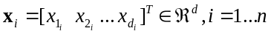, (1)
where d is the dimension of the vector x_{i} with the elements 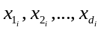, n is the total number of records of the dataset, and T stands for matrix transposition. The expression of the dataset is
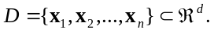, (2)
The algorithm consists in five steps that are performed in an iterative manner over the dataset until obtaining the final clusters defined as
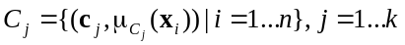, (3)
where k is the number of clusters, c_{j} is a centroid
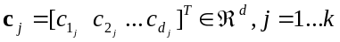, (4)
its elements are 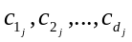, the total number k of centroids equals the number of clusters, 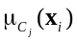 is the membership degree of point (or record or element) x_{i} to cluster C_{j}
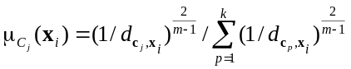, (5)
where m>1 is the fuzzification parameter, p, p=1...k, is the index of a centroid, and 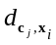 is the distance between record x_{i} and centroid c_{j}, defined as the metric
(6)
The centroids for all clusters are grouped in the centroid matrix c
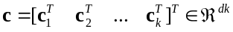. (7)
The main objective of FCM algorithm [14] is to minimize the intra-cluster variance, and it can be formulated in terms of the clustering problem expressed as the optimization problem
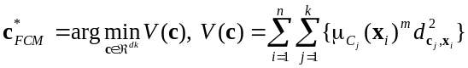, (8)
where c_{j} is the centroid of the cluster C_{j}, x_{i} is a dataset record defined in (1), 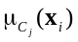 is the membership degree of point x_{i} to cluster C_{j}, and 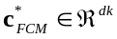 is the solution to optimization problem, also called the optimum centroid vector, with the general definition given in (7).
The general notation η will be used as follows for the current iteration of the algorithms, η=1...η_{max}, where η_{max} is the maximum number of iterations, which needs to be initialized. This notation will be inserted as the superscript (η) to point out the value of a vector or variable at a certain iteration of FCM algorithm.
The steps of FCM algorithm are FCM1 to FCM6:
Step FCM1. Initialize the iteration index η=1 and the number k of clusters.
Step FCM2. Initialize the centroid vector c⁽¹⁾, i.e., the initial value of the solution to (8)
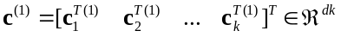. (9)
Step FCM3. Compute the distances 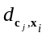 for each combination of records x_{i}, i=1...n, and centroids c_{j}, j=1...k, using (6).
Step FCM4. Build the membership matrix 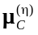
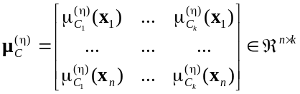, (10)
where the elements of the matrix, 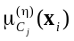, i=1...n, j=1...k, are computed in (5).
Step FCM5. Compute the new centroids used in the next iteration in terms of the following relationship:
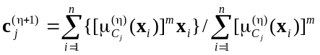, (11)
where j=1...k, and express the centroid vector used in the next iteration:
. (12)
Step FCM6. Test if FCM algorithm has found an optimal solution. The stopping criteria used to check if the algorithm has found a solution are composed by as pair of one inequality and one equality. The first stopping criterion checks that all centroid vectors are modified within a threshold with the width less than ε > 0 after two consecutive iterations. This first stopping criterion is expressed as the inequality
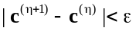. (13)
If the condition (13) is fulfilled, this means that the algorithm is complete and the solution to (8) is the last c^{(η+1)} obtained so far:
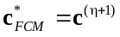. (14)
If the condition (13) is not fulfilled, it is checked if the second stopping criterion is fulfilled, i.e., the next equality is used which indicates that the maximum number of iterations is reached:
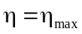. (15)
If the condition (15) is fulfilled, the algorithm is complete and the solution to (8) is given in (14). Otherwise, a new iteration will be performed, i.e., η is replaced with η+1 and the algorithm will continue with step FCM2.
The stopping criteria given in (13) and (15) are not the one generally ones used in FCM. In FCM the stopping criteria is assigned considering the maximum difference between the membership degrees of a certain point at a certain cluster obtained during the iteration and those obtained in the previous iteration. This different approach enables the unified formulation of both algorithms.
As pointed out in the classical papers [18, 34, 55], FCM algorithm is designed such that to solve the clustering problem expressed as the optimization problem defined in (8). The computation in accordance with (11) of the new centroids 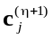 used in the next iteration and their grouping in (12) in the centroid vector c^{(η+1)} used in the next iteration will ensure the decrease of the value of the objective function V in (8) at each iteration. Therefore, the convergence of FCM algorithm to the solution 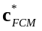 will be guaranteed.
Step FCM1 is an initialization step, and it is executed only once. The number of clusters k will remain constant along all iterations of the algorithm.
The initial choice of centroid vector c⁽¹⁾ is important. Different initializations of c⁽¹⁾ can cause different evolutions of FCM algorithm and make it converge to the same result but with different numbers of iterations.

